Tutorial Week -2

22mx113-M.Ramesh

Mysql and Jsp program:

Creating a Java Web Project

1. Open eclipse and create a new Java Web Project

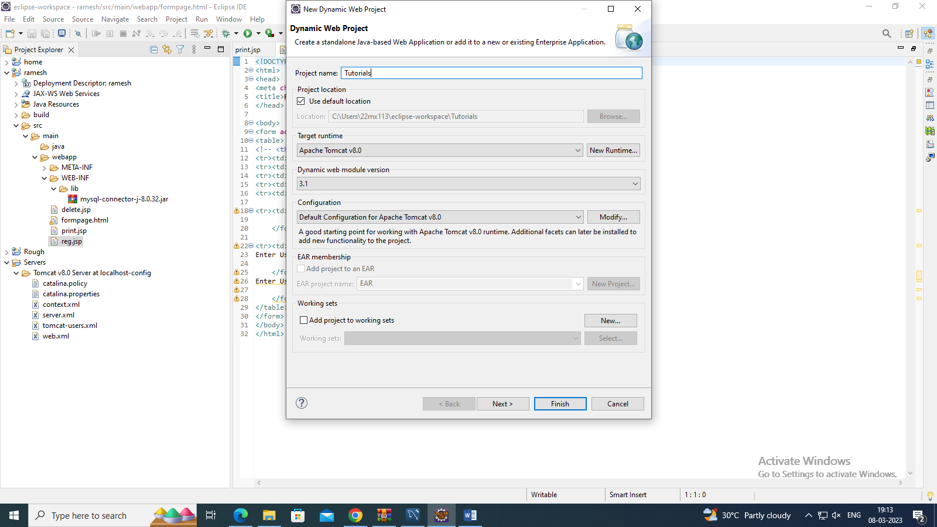

2. Create a form in formpage.html to get input from the user.

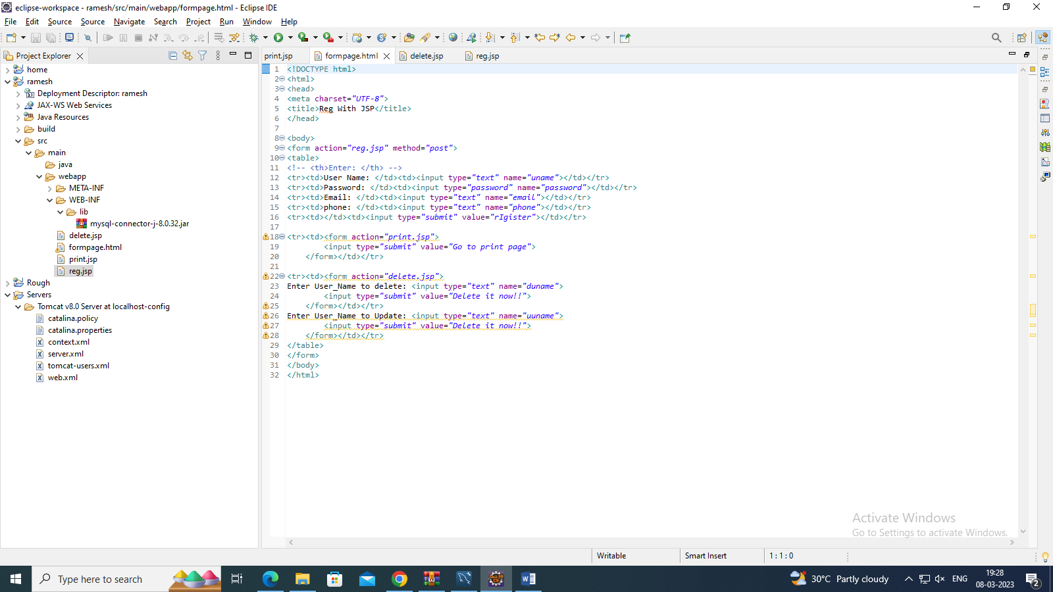

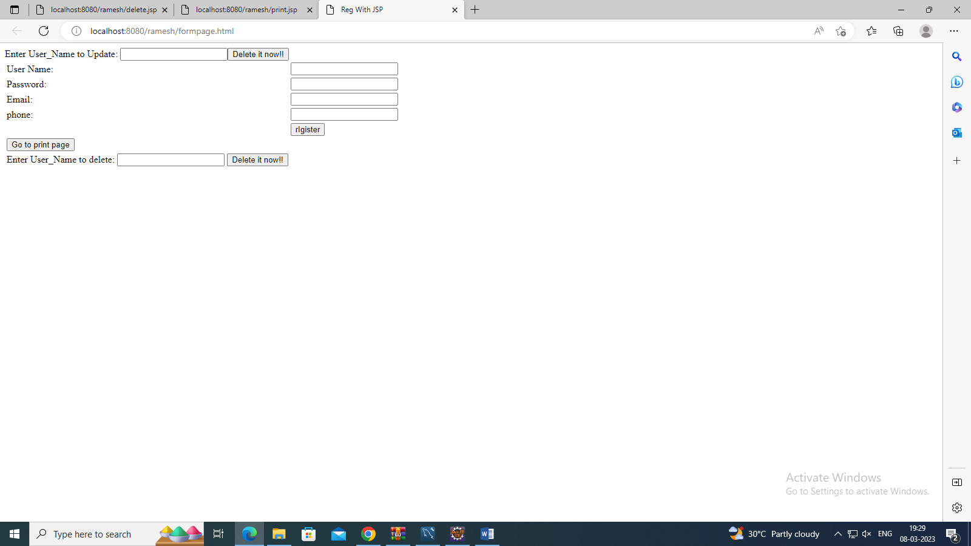

3. Create a JSP file in which the form post data is send.

4. Create a New Connection in Services→Databases→ New Connection

5. Specify the Connecter Information and Database credentialsin Mysql.

6. In Mysql Create Schema name start doing the further procss:

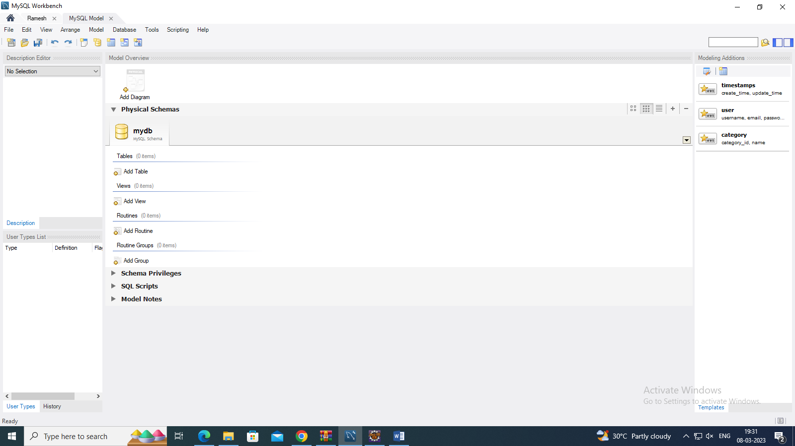

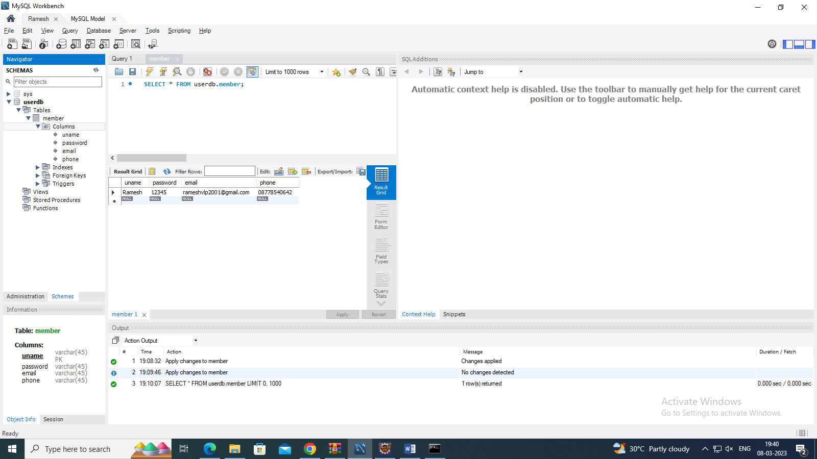

7. Insert Values in a form:

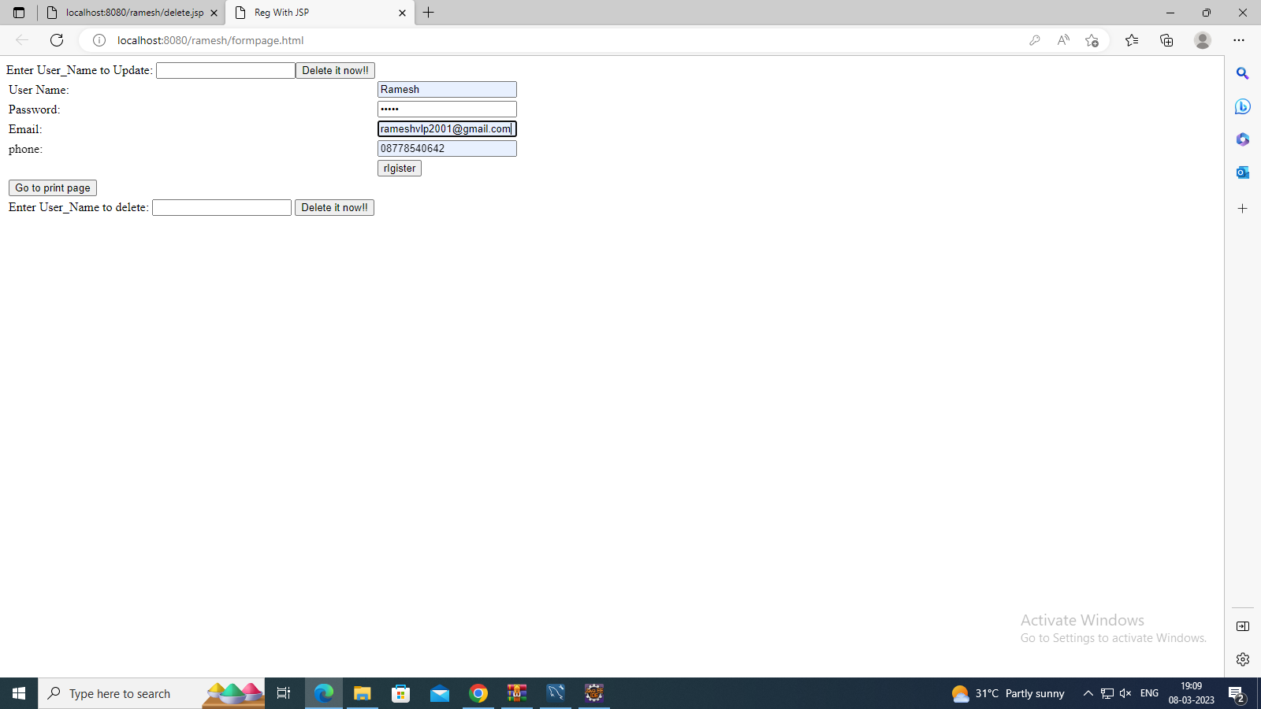

8.Check in the Mysql whether the values are stored in table: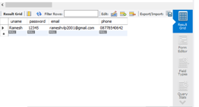

9.Performing a delete Operation in the table :

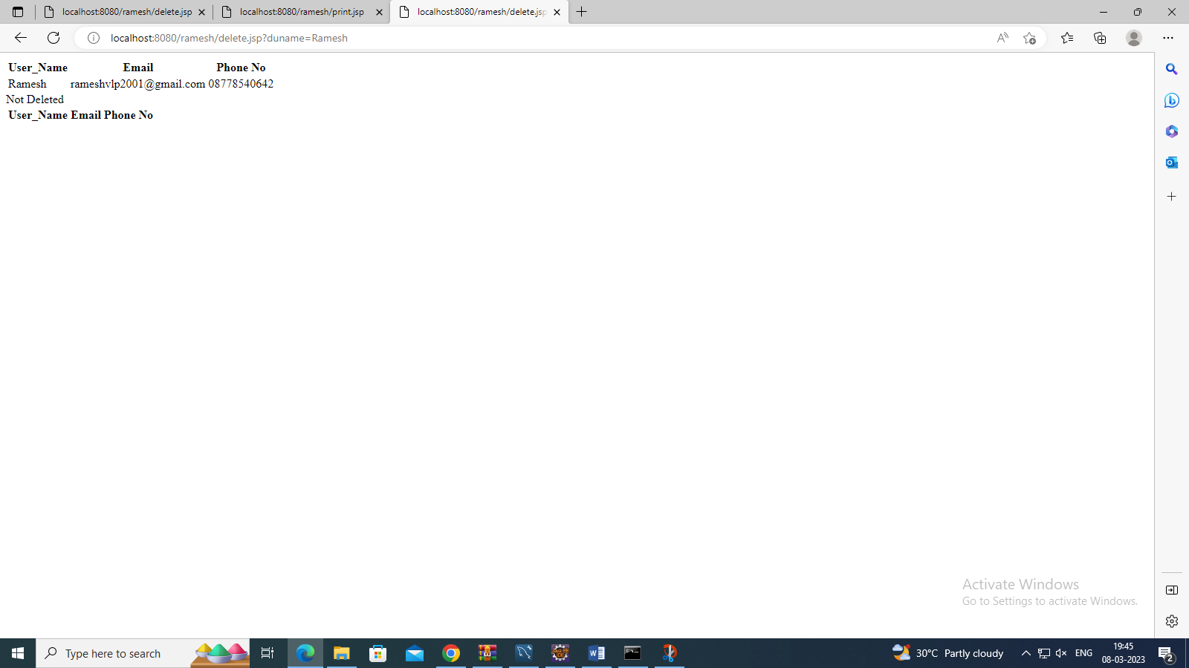

Code:

1Formpage.html

<!DOCTYPE html>

<html>

<head>

<meta charset=*"UTF-8"*>

<title>Reg With JSP</title>

</head>

<body>

<form action=*"reg.jsp"* method=*"post"*>

<table>

<!-- <th>Enter: </th> -->

<tr><td>User Name: </td><td><input type=*"text"* name=*"uname"*></td></tr>

<tr><td>Password: </td><td><input type=*"password"* name=*"password"*></td></tr>

<tr><td>Email: </td><td><input type=*"text"* name=*"email"*></td></tr>

<tr><td>phone: </td><td><input type=*"text"* name=*"phone"*></td></tr>

<tr><td></td><td><input type=*"submit"* value=*"rIgister"*></td></tr>

<tr><td><form action=*"print.jsp"*>

<input type=*"submit"* value=*"Go to print page"*>

</form></td></tr>

<tr><td><form action=*"delete.jsp"*>

Enter User_Name to delete: <input type=*"text"* name=*"duname"*>

<input type=*"submit"* value=*"Delete it now!!"*>

</form></td></tr>

Enter User_Name to Update: <input type=*"text"* name=*"uuname"*>

<input type=*"submit"* value=*"Delete it now!!"*>

</form></td></tr>

</table>

</form>

</body>

</html>

2.print.jsp

<%@ page import=*"java.sql.*"* %>

<%

// Establish a connection to the MySQL database

Class.forName("com.mysql.jdbc.Driver");

Connection con = DriverManager.getConnection("jdbc:mysql://localhost:3306/userdb","root","admin");

// Execute a SQL SELECT statement to retrieve data from the database

Statement stmt = con.createStatement();

ResultSet rs = stmt.executeQuery("SELECT * FROM userdb.member");

// Iterate over the ResultSet and print the data to the user

out.println("<table>");

out.println("<tr><th>User_Name</th><th>Email</th><th>Phone No</th></tr>");

**while** (rs.next()) {

String uname = rs.getString("uname");

String email = rs.getString("email");

String phone = rs.getString("phone");

out.println("<tr><td>" + uname + "</td><td>" + email + "</td><td>"+phone+"</td></tr>");

}

out.println("</table>");

// Close the database connection, statement, and ResultSet

rs.close();

stmt.close();

con.close();

%>

3.reg.jsp

<%@ page language=*"java"* contentType=*"text/html; charset=UTF-8"*

pageEncoding=*"UTF-8"*%>

<%@ page import = *"java.sql.*"*%>

<%

String uname = request.getParameter("uname");

String password = request.getParameter("password");

String email = request.getParameter("email");

String phone = request.getParameter("phone");

**try**{

Class.forName("com.mysql.jdbc.Driver");

Connection conn = DriverManager.getConnection("jdbc:mysql://localhost:3306/userdb","root","admin");

PreparedStatement ps = conn.prepareStatement("insert into userdb.member values(?,?,?,?);");

ps.setString(1,uname);

ps.setString(2,password);

ps.setString(3,email);

ps.setString(4,phone);

**int** x = ps.executeUpdate();

**if**(x>0){

out.println("Registration done.");

response.sendRedirect("print.jsp");

}

**else** {

out.println("Registration failed.");

}

} **catch**(Exception e){

out.println(e);

}

%>

4.delete .jsp

<%@ page import=*"java.sql.*"* %>

<%

Class.forName("com.mysql.jdbc.Driver");

Connection con = DriverManager.getConnection("jdbc:mysql://localhost:3306/userdb","root","admin");

Statement stmt = con.createStatement();

ResultSet rs = stmt.executeQuery("SELECT * FROM userdb.member");

out.println("<table>");

out.println("<tr><th>User_Name</th><th>Email</th><th>Phone No</th></tr>");

**while** (rs.next()) {

String uname = rs.getString("uname");

String email = rs.getString("email");

String phone = rs.getString("phone");

out.println("<tr><td>" + uname + "</td><td>" + email + "</td><td>"+phone+"</td></tr>");

}

out.println("</table>");

String dn = request.getParameter("duname");

String sql = "DELETE FROM userdb.member WHERE uname = \""+dn+"\" ";

//stmt = con.createStatement();

**if**(stmt.executeUpdate(sql)>0){

out.println("Deleted: "+dn);

}

**else** {

out.println("Not Deleted");

}

ResultSet rs2 = stmt.executeQuery("SELECT * FROM userdb.member");

out.println("<table>");

out.println("<tr><th>User_Name</th><th>Email</th><th>Phone No</th></tr>");

**while** (rs2.next()) {

String uname = rs2.getString("uname");

String email = rs2.getString("email");

String phone = rs2.getString("phone");

out.println("<tr><td>" + uname + "</td><td>" + email + "</td><td>"+phone+"</td></tr>");

}

out.println("</table>");

rs.close();

stmt.close();

con.close();

%>